**DAILY ONLINE ACTIVITIES SUMMARY**

|  |  |  |  |  |  |  |  |
| --- | --- | --- | --- | --- | --- | --- | --- |
| **Date:** | **31/05/2020** | | | | **Name:** | **K ISHA HEGDE** | |
| **Sem & Sec** | **4th SEM 'A' Section** | | | | **USN:** | **4AL18CS031** | |
| **Online Test Summary** | | | | | | | |
| **Subject** | | **N/A** | | | | | |
| **Max. Marks** | | **N/A** | | **Score** | | **N/A** | |
| **Certification Course Summary** | | | | | | | |
| **Course** | **INTRODUCTION TO INFORMATION SECURITY** | | | | | | |
| **Certificate Provider** | | | **1. Great Learning Academy** | **Duration** | | | **2.45hrs** |
| **Coding Challenges** | | | | | | | |
| **Problem Statement:** 1. Write a Java program to calculate nPr.  .  For example | | | | | | | |
| **Status: completed** | | | | | | | |
| **Uploaded the report in Github** | | | | **Yes** | | | |
| **If yes Repository name** | | | | **[https://github.com/iishaii/locked-down_coding](https://github.com/iishaii/locked-down_coding" \o "https://github.com/iishaii/locked-down_coding)** | | | |
| **Uploaded the report in slack** | | | | **Yes** | | | |

Certification Course Details: I have started with the new course INTRODUCTION TO INFORMATION SECURITY.The duration of course is 5.5 hrs.This is especially important in a business environment increasingly interconnected, in which information is now exposed to a growing number and a wider variety of threats and vulnerabilities. Cause damage such as malicious code, computer hacking, and denial of service attacks have become more common, more ambitious, and more sophisticated. So, by implemented the information security in an organization, it can protect the technology assets in use at the organization.

Snapshot:

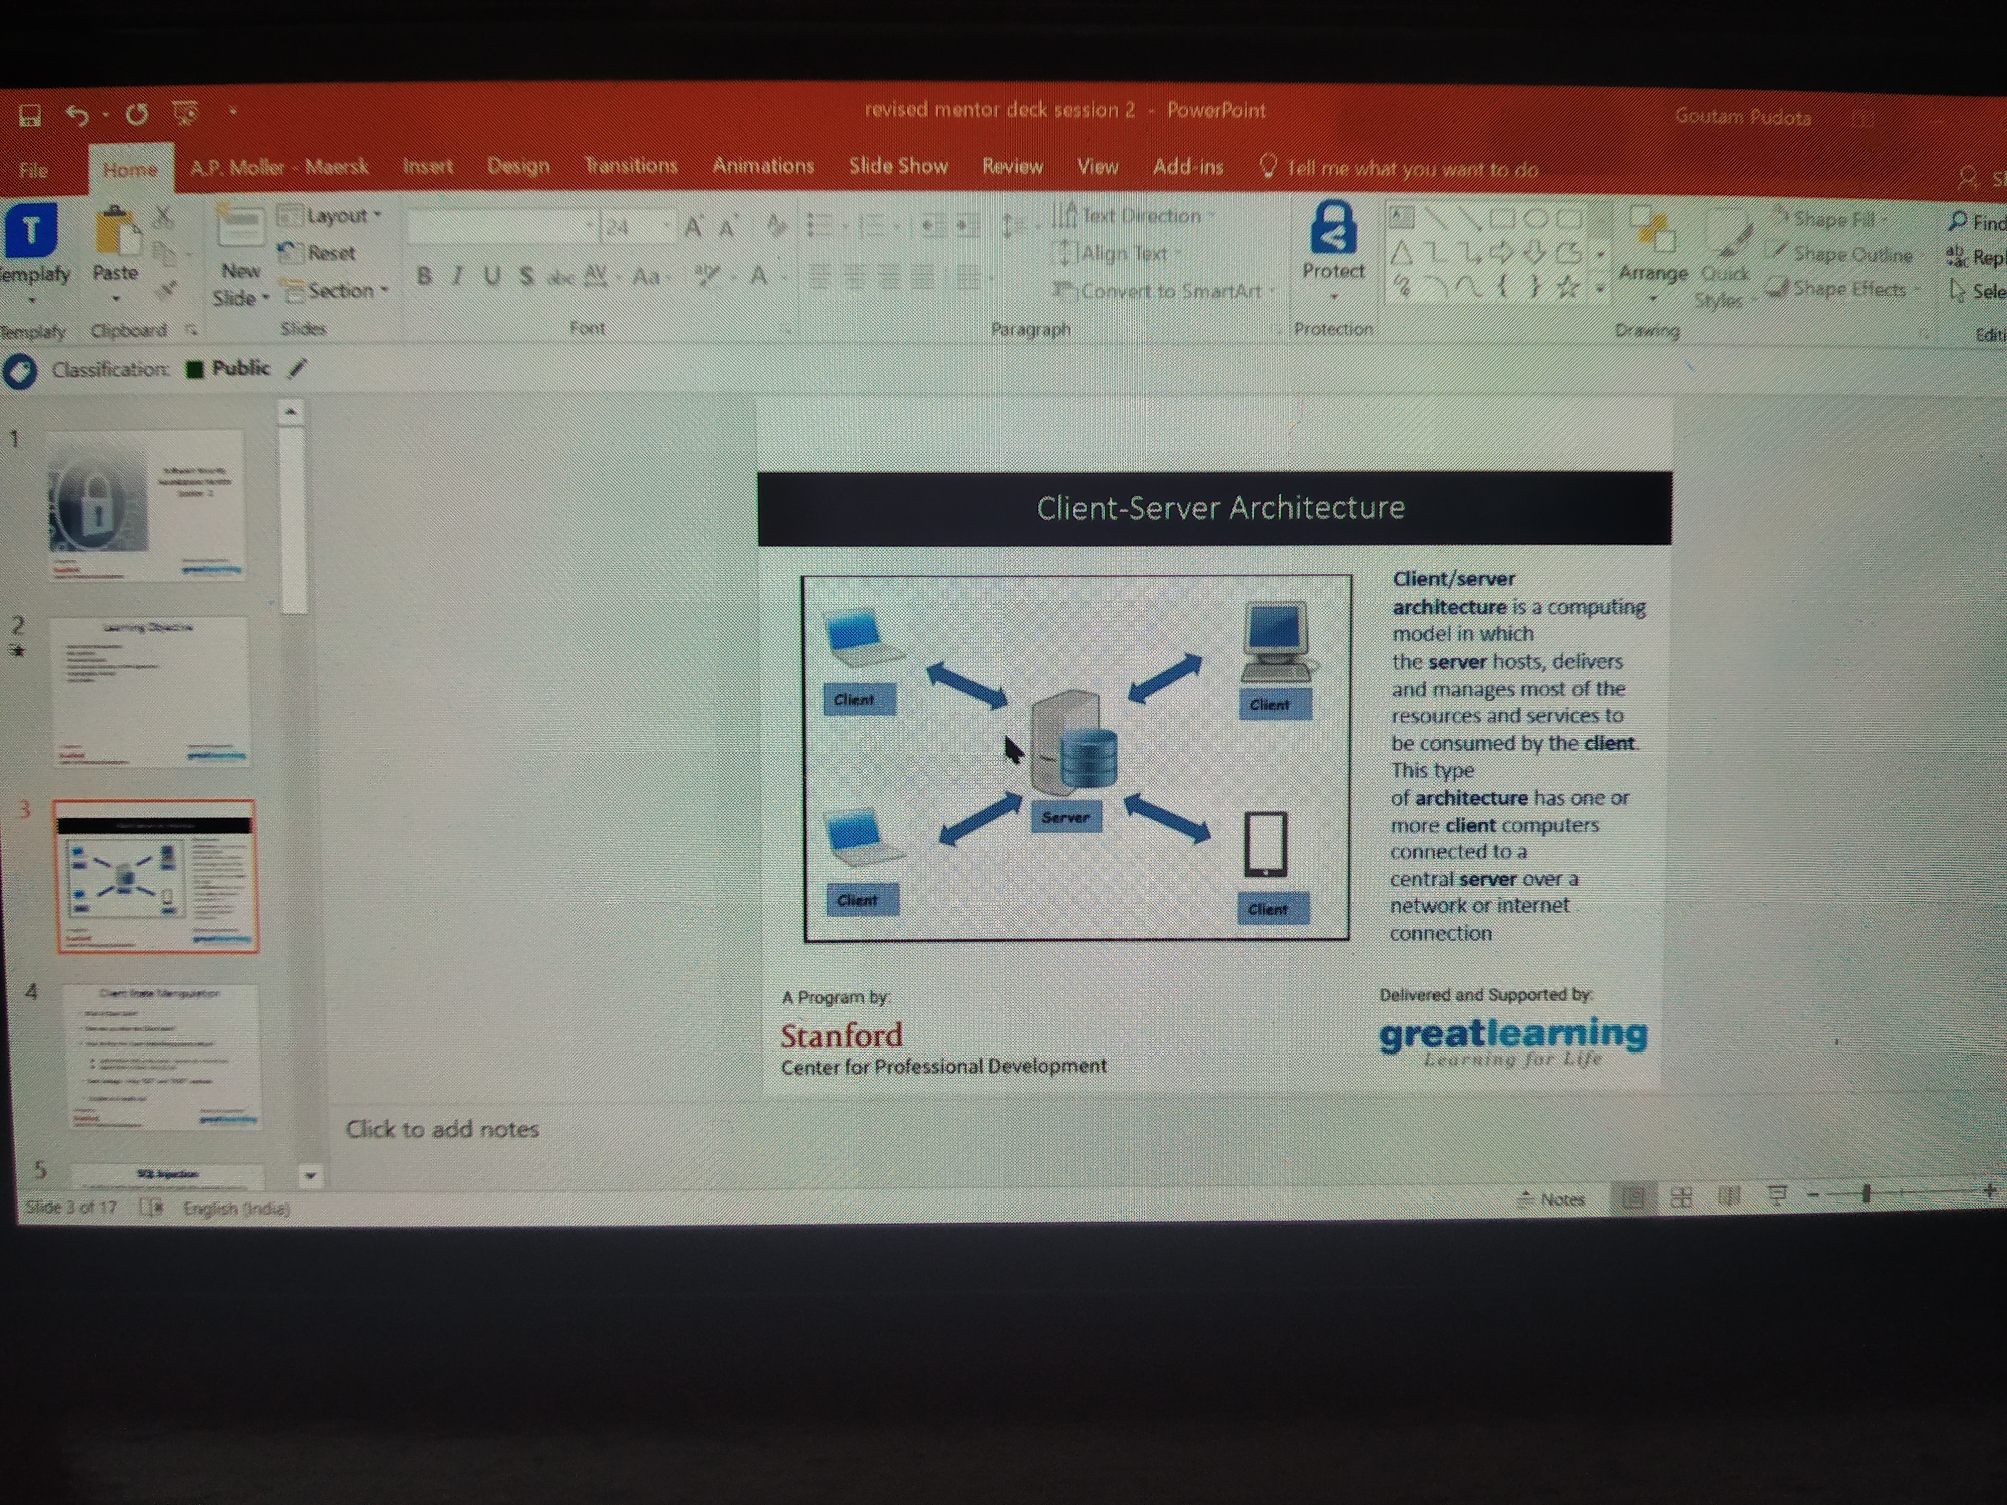

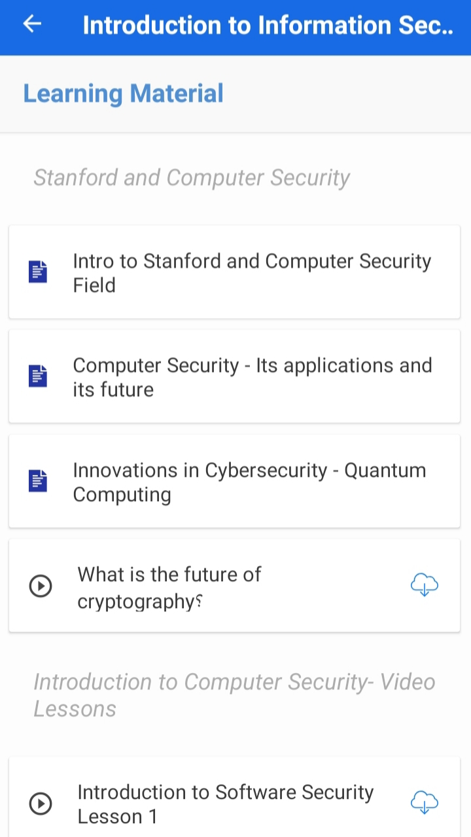

CODING CHALLENGES DETAILS: Problem statements

1. Write a Java program to calculate nPr.

Solution: Uploaded it in github

Snapshot:

